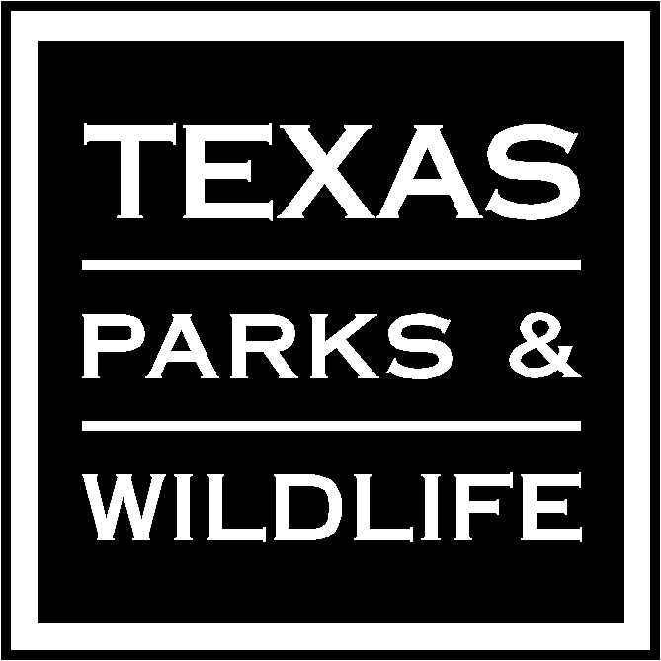

CERTIFICATION FOR RECREATION GRANTS
REIMBURSEMENT REQUEST

I certify that the attached reimbursement request for the
period of January 1, 2017 to April 30, 2017 for
Project Name Bobcat Woods Trail Extension, Project Number RT15011 is correct and just, and is based upon actual payment(s) of record by the participant political subdivision; that payment from the State of Texas has not been received; that the work and services are in accordance with the Texas Parks and Wildlife Department Recreation Grants Program, including amendments thereto; and that progress of the work and services under the project agreement is satisfactory and is consistent with the amount billed.

Friends of Brazoria Wildlife Refuges
Political Subdivision (Sponsor)

By Martin Cornell
Signature

Martin Cornell
Print or Type Name and Title

May 1, 2017
Date

AMOUNT REQUESTED: $68,249.14 (80% of total expenses including in-kind labor and equipment value)

