Dow Woods Project
Revised Report to FOBWR Board of Directors
Neal McLain 02/14/10

As most of you know, Friends of Brazoria Wildlife Refuges has received a substantial grant from Texas Parks and Wildlife Department for the construction of trails and restroom facilities at the Dow Woods Unit of San Bernard National Wildlife Refuge. Marty Cornell prepared the grant application, and we recently received funding.

Jennifer Sanchez asked me to take over this project during Marty Cornell's absence. This is a revised version of the status report I submitted to the Board on 02/11/10. Changes in this revision include additional information about trail construction plans and clarification of the location of the Hamilton-Jackson Canal ("slave ditch").

TRAILS

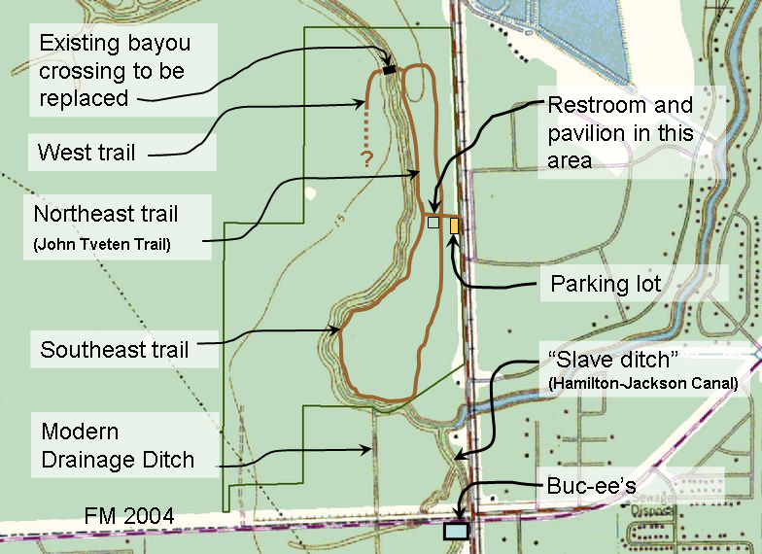
Three trails are planned:

Note that the Hamilton-Jackson Canal connects to Bastrop Bayou at a point located on private property. It is not visible from the proposed route of the southeast trail

2

Several of us have walked out the northeast trail to establish the route, determine where boardwalks will be required to cross over wetlands, and to measure the trail for budgetary purposes:

- USFWS personnel Tom Schneider and Shane Kasson moved through first to determine the best route for the trails.

- FOBWR and TMN-COT volunteers Ed Johnson, Denis Mudderman, Archie Pratt, and I followed along behind to document GPS waypoints. We established a waypoint at every turn or bend in the trail route, and at significant natural or historic features along the trail.

The western portion of the northeast trail follows the eastern shore of Bastrop Bayou. During our walkout, we identified locations where boardwalks will be required to provide access to viewpoints overlooking the bayou, or to cross wetlands.

We are currently reviewing options for constructing the trail and the boardwalks. We anticipate that we will select an outside contractor to build the trails. Two TMN-COT volunteers—Kirby Rapstein and Billy Heck—have tentatively agreed to build the boardwalks if they are not included in the trail-construction contract.

We are currently working on the southeast trail walkout. Work on the west trail is on hold at the moment, pending the results of engineering studies related to the existing bayou crossing.

RESTROOM

USFWS is planning to construct waterless double restroom, with an attached storage room, located about 400 feet west of the existing parking lot. Based on Marty's preliminary work, I have prepared procurement specifications for this building. As soon as we receive USFWS approval, we will issue the specs to potential bidders.

PAVILION

Future plans call for a pavilion near the trail between the parking lot and the bayou. The Pavilion is expected to be similar to existing structures at San Bernard NWR and Brazoria NWR.

The present grant does not include funding for the pavilion. We hope of obtain funding by means of a future grant.

