P. O. Box 505  
Lake Jackson TX 77566

979-297-1815

president@refugefriends.org

http://refugefriends.org

***Board of Directors***

*President*

Lisa Ladd Myers

*Vice President*

Ed Barrios

*Secretary*

Marty Cornell

*Treasurer*

Regina Tippett

*Members at Large*

Oron Atkins

Mickey Dufilho

Phil Huxford

Ruby Lewis

Herb Myers

Kim Richardson

Richard Schaffhausen

Mary Schwartz

***Advisory Board – USFWS***

Jennifer Sanchez

The Friends of Brazoria Wildlife

Refuges is a non-profit 501(c)(3)

Corporation.   
Tax ID # 76-0440298

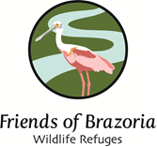

date

address

Re:

Dear

body

Body page 2