Friends of Brazoria Wildlife Refuges
P. O. Box 505
Lake Jackson, TX 77566-0505

On behalf of
United States Department of the Interior
United States Fish & Wildlife Service
Texas Mid-coast National Wildlife Refuge Complex
San Bernard National Wildlife Refuge
6801 County Road 306
Brazoria, Texas 77422-7896
Telephone 979-964-3639
Fax 979-964-3210

Request for Proposal for
DOW WOODS CROSSING
to be constructed at
Dow Woods Unit of San Bernard National Wildlife Refuge
located in
City of Lake Jackson, Brazoria County, Texas

CONTENTS

Section 1. Job Site map 2
Section 2. Definitions of terms used in this document 3
Section 3. Scope of Work 5
Section 4. Bid process 6
Section 5. Bidder Information Form 7
Drawing Culvert Plan Sheet A
Drawing Culvert Cross Section Sheet B

GENERAL SCOPE OF THE PROJECT
Remove an existing trail crossing across Bastrop Bayou in the Dow Woods Unit of San Bernard National Wildlife Refuge.
Construct a new trail crossing across Bastrop Bayou at the same location
The entrance and parking lot at Dow Woods Unit are accessible off Old Angleton Road (County Road 288) 0.8 miles north of FM 2004, in Lake Jackson, Texas.
Approximate coordinates at site: 29.080667, -95.430383

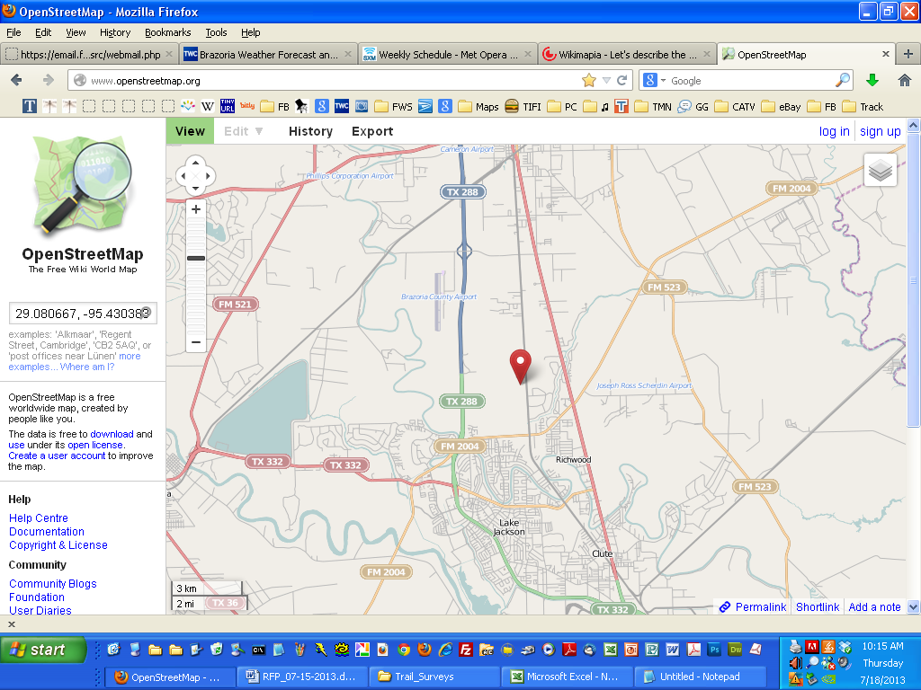
Section 1. Job site map.
Section 2. Definitions of terms used in this RFP
Job site
29.080667, -95.430383
Base map © OpenStreetMap Contributors. Cartography licensed under Creative Commons Attribution-ShareAlike 2.0 license (CC-BY-SA).

- Acceptance Date - The date on which the on which the trail is completed and accepted by the Owner.

- A/R - As required.

- Bids Due Date - See Section 4 of this RFP.

- CR - County Road

- Complex - The Owner as defined herein.

- Dow Woods Crossing - The structures defined in this RFP.

- DWU - Dow Woods Unit of the San Bernard National Wildlife Refuge. DWU is located near the City of Lake Jackson, Texas, northwest of the intersection of State Highway FM 2004 and County Road 288. See Job Site Map, Page 2.

- FM - Farm-to-Market Road.

- FOBWR - Friends of Brazoria Wildlife Refuges, a non-profit 501(c)(3) corporation whose mission is to provide support to the Owner. Tax ID number 76-0440298.

- Inspector - The Owner's Inspector as defined herein. The manager of the San Bernard National Wildlife Refuge will identify the inspector when the winning bidder is selected.

- Job Site - The location of the structure described in this RFP and the immediate surroundings. Not to be confused with Work Site (see below).

- NIC - Not in contract.

- Owner - United States Department of the Interior, United States Fish & Wildlife Service, Texas Mid-Coast National Wildlife Refuge Complex. The Owner's office is located at 2547 County Road 316, Brazoria, TX 77422-7703.

- Owner's Inspector - the person designed by the Owner to inspect the trail during construction.

  - Purchaser - Friends of Brazoria Wildlife Refuges

  - RFP - Request for Proposal (this document).

  - SH - State Highway

- Contractor - The person or entity whose bid is accepted by owner pursuant to this RFP.

- Typ - Typical

- USFWS - United States Fish & Wildlife Service.

- Warranty - The completed trail and all of its associated components shall be warranted against defects in materials and workmanship for a period of not less than one year from the Acceptance Date.

- Work Site - The entire Dow Woods Unit of the San Bernard National Wildlife Refuge as defined herein. This term shall be interpreted to include the parking lot and all areas within the Dow Woods Unit where construction is to take place pursuant to this RFP. Not to be confused with Job Site (see above).

Section 3. Scope of Work.

- Before starting construction, meet with the owner's inspector to identify an access route between the parking lot and the job site for construction equipment. The route will be chosen to minimize disturbance to the grounds and facilities.

- Install Best Management Practices (BMP’s) to prevent the transport of disturbed sediment both up and downstream of the project site (silt fences, hay bales, etc.)

- Remove and dispose of existing culvert crossing and associated structures/debris.

- Excavate sediment to create stable platform for new crossing – material to be used on site for bank stabilization.

- Place and grade rip rap (6”-24”) base as shown on engineers drawings
identified
2R-TX-768-Sheet A
2R-TX-768-Sheet B

- Place and grade bull rock (4”-6”) where ends of culverts will be (see drawings).

  - Place and level two 54’ sections of 45”x73”x6” (HxWxTh) Reinforced Concrete Arch pipe (ASTM C506 Class A-11). Use RAM-NEK concrete joint sealant between all individual pipe sections

- Place and grade remaining rip rap to slopes and grade specified in drawings.

- Place, grade and compact 10’ wide decomposed granite gravel trail over rip rap where shown on drawings.

- Remove all remaining material and construction equipment, repairing any surface damage upon exit.

Section 4. Bid process.
- Pre-bid inspection: The Dow Woods Unit is open to the public from sunrise to sunset. Bidders may visit the site during these hours. To reach the site, park in the lot (off Old Angleton Road 0.8 mile north of FM2008), and proceed north on foot along the John Tveten Trail to 29.080667, -95.430383. The job site is visible from this point.

- Form of bid: Bidder shall propose a single price for the entire job as set forth in this RFP. Each bid must include the Dow Woods Crossing Bidder Information Form (Section 5 of this RFP).

- Bid due date: _______________________

- Acceptance date: The acceptance date will be defined by the manager of the San Bernard National Wildlife Refuge, or his designee, after final inspection by the owner's inspector. The one-year warranty period, as defined herein in Section 2, shall begin on the acceptance date.

Section 5. Bidder Information Form

All bids must include the following form or a facsimile including the same information:

Full legal name of bidder: _______________________________________________

______________________________________________________________________

Legal status of bidder:
Sole Proprietorship (SSA Number _______________________________)
Partnership (SSA Number of partner submitting bid __________________)
Corporation (Federal Tax ID Number _____________________________)

Signature of person submitting this bid: ___________________________________

Print Name: ___________________________________________________________

Title of person submitting this bid: _______________________________________

Mailing address of bidder: ______________________________________________

_____________________________________________________________________

Telephone number of bidder: ____________________________________________

Fax number of bidder: __________________________________________________

Email address of bidder: ________________________________________________
Completed bids must be mailed or delivered to the following location:

Texas Mid-coast National Wildlife Refuge Complex
San Bernard National Wildlife Refuge
Attn: Dow Woods Crossing Bid
6801 County Road 306
Brazoria, Texas 77422-7896

